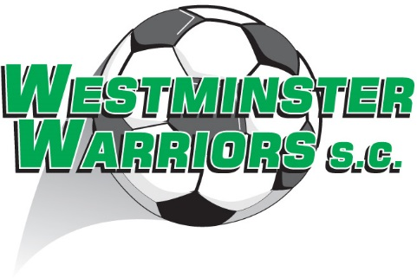

What gear do I have to buy?

Must have: Club shorts and socks, (both purchased through the Club Equipment Shop), shin pads, boots (jerseys provided by the Club)

Should have: Soccer ball (for training and self-learning); water bottle (for training and games)

Could have: Club cap; club jacket

No players are permitted to take part in any training or fixture matches unless they are wearing shin pads and shoes/soccer boots.

Note that soccer balls come in three sizes: Size 3 (Under 7 & 8); Size 4 (Under 9 to Under 13); Size 5 (Under 14 and older).

Every new player receives a free supporter shirt once they have paid their fees in full (shirts may not be available at sign-on).

