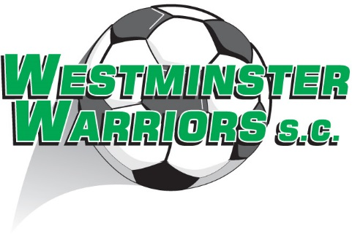

What do my fees include?

- Association Fees (QCSA);
- Basic Player Insurance;
- Team Photo;
- Trophy;
- Playing Jersey;
- Supporter Shirt for all new players only in 2023;
- Playing Equipment including goals, game balls, bibs, bags, cones, etc.;
- Coaching Courses and Coaching Aids;
- Various fun days and carnivals;
- Club presentation day ;
- Building & Grounds Cleaning and Maintenance;
- Contents Insurance;
- Equipment Capital Expenditure and Maintenance;
- Utility Costs;
- Volunteer Levy; and
- Administrative Costs.

